EXERSISE
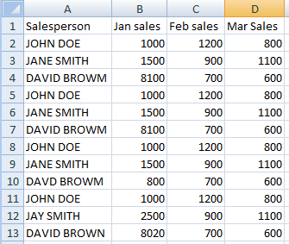
Step :1 To create excel table

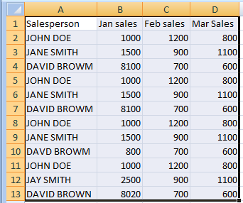
Step :2 Then select the excel table

Step:3 Then go to the ribbon and select the insert option

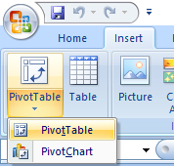
Step :4 then select the ‘PIVOT TABLE’

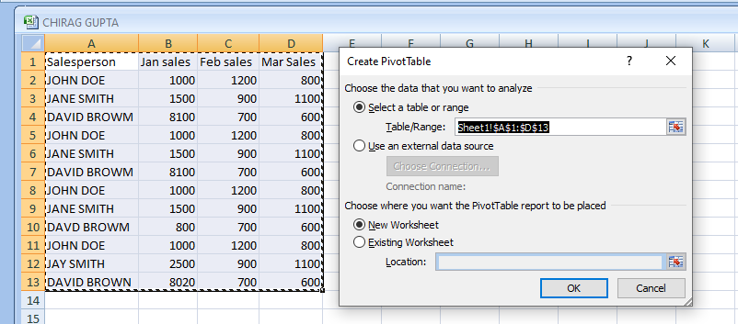
Step :5 then we see the create pivot table window and select new window option

